To Kill a Mockingbird

This theme journal belongs to:
_________________________________
Avoid writing explanations in first person. Be concise and make
inferences related directly to your cited text and the theme.
Remember to cite your text examples!

Racism and Inequality
Text | Explanation
“Scout, I'm tellin' you for the last time, shut your trap or go home—I declare to the Lord you're gettin' more like a girl every day! With that, I had no option but to join them.” (page ______) | When Jem says this to Scout, she is being shamed for objecting to his reckless behavior. What’s wrong with pointing out reckless behavior, and why is this associated with acting like a girl? Furthermore, Jem’s comment assumes girls are nags or no fun!
 | 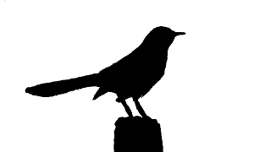
Courage
Text | Explanation
 | 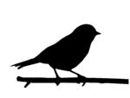
Human Morality
Text | Explanation
Coming of Age
Text | Explanation
 | 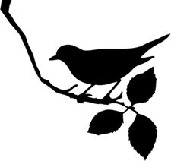
Justice and Judgment
Text | Explanation
 | 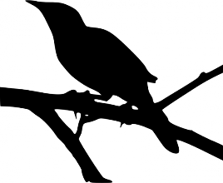
Compassion and Forgiveness
Text | Explanation

