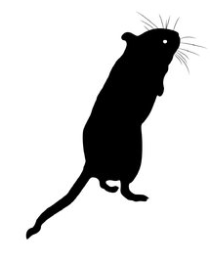
______________________________________
Of Mice and Men
Anticipation Guide
Of Mice and Men Anticipation Guide

______________________________________

______________________________________

______________________________________

John Steinbeck’s book takes place during a challenging time in our history. As a writer, he makes several points and poses questions through his characters and plot. Here are some questions to “wet your whistle” before we read. For each of the statements, it’s time to pick a side! Once you’ve made your decision, write ONE concise and precise statement to support your choice on your chosen side of the fence.

Yep! I agree. | Statement | I disagree! How could you not?
 | We have no control over most things that happen to us.
 | Feeling responsible for someone is a burden.
 | Of the many feelings that hurt, loneliness is the most painful.
 | Society can’t defeat us; only a flaw in our personality can do that.
 | Dreaming is for dreamers, and dreamers go nowhere. Face it. | 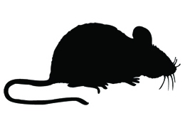
That is so true! | Statement | No way! What are you thinking?
 | Sometimes it’s necessary to hurt someone in order to really help him/her.
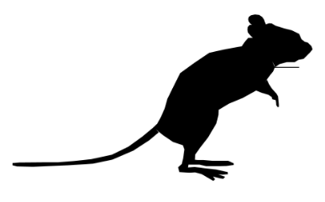 | A true friend will always tell you the truth, even when you don’t want to hear it.
 | Sometimes it’s necessary to take the law into your own hands when justice isn’t served through the courts.
 | If people are lonely, it’s their own fault.
 | People with a bad reputation have earned it.
 | Physical abuse is worse than verbal abuse.
 | It is more socially acceptable for women to love their female friends than it is for men to love their male friends.
 | We have no control over most things that happen to us. | 