Complex Sentences
- Circle the subordinate conjunction.
- Underline the dependent clause.
- Highlight the independent clause.

- Unless we do all of our homework, we won’t be able to play.
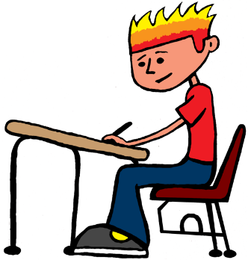
- My dog waited at the door for us until we got home.
- Although none of us wanted to leave, we had to be home before midnight.
- If Charlie doesn’t stop teasing that dog, the dog is going to bite him.
- We took pictures while the monkeys swung from the trees.
- Whenever my sister gets in trouble, my dad makes her weed the garden.
- Once school starts, you need a pass to get into your class.
- Before you accuse someone of stealing your pencil, make sure it isn’t just lost.
- I had to go to the dentist because my back tooth started to hurt.
- After I finished my project, I asked my dad to check it for mistakes.

